# Automatic tracking vehicle

**Two-circuit tracking sensor:** The probe of the tracking sensor is an infrared pair tube, one emitting infrared and the other receiving. Within a certain distance, when the tracking sensor is aimed at a white object (a bright object), the emitted infrared ray will be sent back and received by the receiving tube. The black object will absorb light, so when the transmitting tube reaches the black object, the infrared ray will be absorbed, and the receiving tube will not receive the infrared ray.

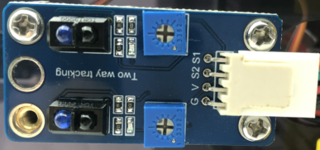

The tracking sensor is a digital sensor, and the measured value is 0 or 1.

## Install the automatic tracking vehicle

Use the structure of the previous lesson.

|  |  |
| --- | --- |
| SSJY2-01 套件 蹦蹦 赛车形态_空白视图 2_27 | SSJY2-01 套件 蹦蹦 赛车形态_空白视图 2_28 |
| SSJY2-01 套件 蹦蹦 赛车形态_空白视图 2_29 | SSJY2-01 套件 蹦蹦 赛车形态_空白视图 2_30 |
| SSJY2-01 套件 蹦蹦 赛车形态_空白视图 2_31 | SSJY2-01 套件 蹦蹦 赛车形态_空白视图 2_32 |
| SSJY2-01 套件 蹦蹦 赛车形态_空白视图 2_33 | SSJY2-01 套件 蹦蹦 赛车形态_空白视图 2_34 |
| SSJY2-01 套件 蹦蹦 赛车形态_空白视图 2_35 |  |
|  | |

## Test the tacking sensor

What we use is a two-circuit tracking sensor. Read the values of it.

1. Example program

|  |
| --- |
|  |

1. **Experiment phenomenon**

The serial port monitor area of SnailBlock prints the value of the tracking sensor. When the sensor is close to the table, the measured value is 0. When it is held up or the sensor is facing a black object, the measured value is 1.

|  |
| --- |
|  |

### Anti-fall alarm

The floor sweeper will not fall down the stairs, so it can use this module to prevent falling.

1. Example program

|  |
| --- |
|  |

1. **Experiment phenomenon**

When the car is high in the air, the buzzer sounds an alarm.

### Tracking vehicle

Now there are some restaurant robots on the market. If you see that there are black tracks on the ground, it is basically realized by using tracking sensors. For example, the following figure.

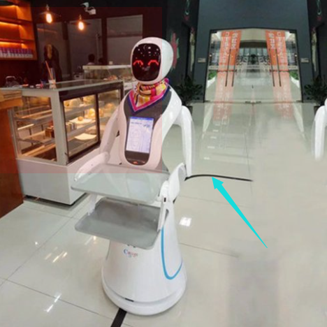

We provide a tracking drawing to realize that the car follows the black line.

**Principle of tracking:**

|  |  |  |
| --- | --- | --- |
| **Left-hand value** | **Right-hand value** | **Direction** |
| **1** | **1** | **advance** |
| **1** | **0** | **Left turn** |
| **0** | **1** | **Right turn** |
| **0** | **0** | **Stop** |

1. **Example program**

|  |
| --- |
|  |

**（2）Experiment phenomenon**

The vehicle automatically follows the black line.

## Draw a circle as a prison

1. Program idea

Circle the vehicle. The vehicle runs in the black circle, but cannot run out of the circle.

Two tracking sensors. When the black line is detected on the left, the vehicle will move to the right. When the black line is detected on the right, the vehicle moves to the left. When the black line is detected on both sides at the same time, step back and then go left.

1. Example program

|  |
| --- |
|  |

**（3）Experiment phenomenon**

The vehicle is placed in the black circle of the drawing, and it cannot go out of the black circle.